**Daisy Board DC**

*Compact, ESP32-powered motor driver with integrated IMU for robotics and IoT projects*

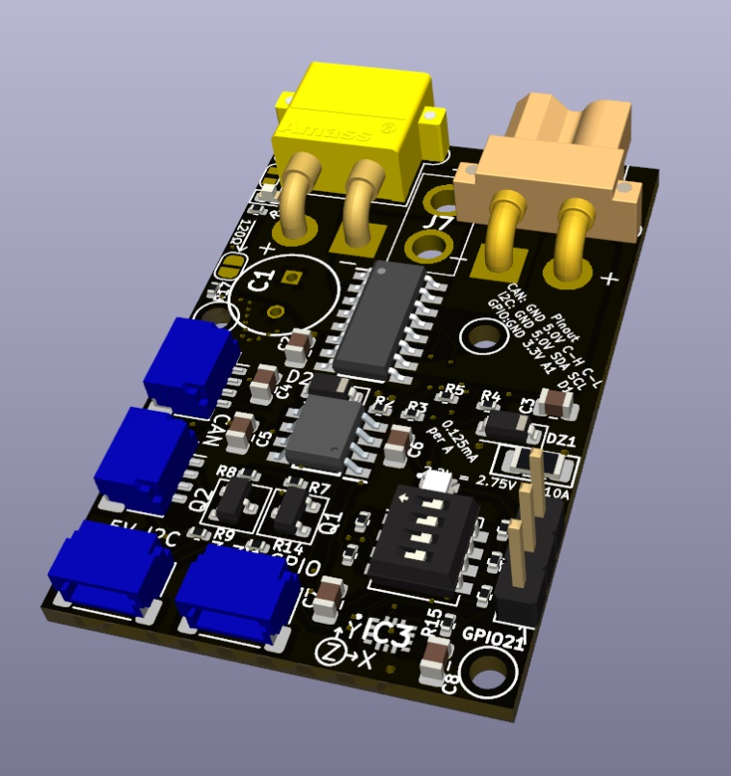**Key Features**:

* Controls DC motors up to 7A continuous, 10A peak.
* Operates with input voltages between 12V and 24V.
* Compact design (1.2" x 1.8") with various communication options: 5V I2C, CAN bus, GPIO.
* Onboard 6-axis IMU for motion tracking and feedback.
* **NO REVERSE POLARITY PROTECTION**

**Manufacturer**: Wilson Fabrication

(PCBWay or JLCPCB)

**Table of Contents**

1. Overview
2. Key Features
3. Specifications
4. Pinouts
5. Functional Description
6. Assembly Notes
7. Ordering Information
8. Contact Information

**1. Overview**

The Daisy Board DC is a feature-rich, compact motor control solution tailored for robotics and smart projects. Powered by the ESP32-C3 microcontroller, this board integrates CAN bus communication for daisy-chaining multiple devices and I2C for easy expansion with sensors or additional modules.

An onboard 6-axis IMU (LSM6DS3TR-C) provides precise motion tracking and orientation feedback, making the board ideal for robotics applications requiring advanced control. The integrated motor driver (VNH7100BASTR) supports up to 7A continuous current and features current-sensing capabilities for real-time monitoring and control.

The Daisy Board DC is designed for maximum flexibility, with connectors for CAN bus, I2C, GPIO, and configurable CAN addressing using a 4-position DIP switch. This robust solution is well-suited for IoT devices, smart home systems, and robotics projects requiring efficient motor control in a small footprint.

**2. Key Features**

* **Power**: Accepts 12V to 24V input, supporting up to 7A continuous current (10A peak).
* **Interfaces**:
  + CAN Bus
  + I2C
  + GPIO
* **Onboard Components**:
  + **Motor Driver**: VNH7100BASTR
  + **CAN Transceiver**: TJA1050T_CM
  + **IMU**: LSM6DS3TR-C (6-axis)
  + **Microcontroller**: ESP32-C3
* **Feedback**: Current sense resistor and 6-axis IMU.

**3. Specifications**

* **Input Voltage**: 12V–24V (30V limit with supported input capacitor)
* **NO REVERSE POLARITY PROTECTION**
* **Max Continuous Current**: 7A (10A peak)
* **PCB Dimensions**: 1.2" x 1.8"
* **Temperature Range**: -40°C to 85°C
* **Pin Connectors**:
  + XT30 (power in/out and motor output)
  + J8 header for GPIO2, 5V, and GND
  + JST SH 4 Pin connectors for CAN, I2C, and GPIO
* **Capacitor and Connectors**:
  + Polarized XT30 connectors and capacitor, clearly labeled for correct orientation.

**4. Pinouts**

|  |  |  |  |  |
| --- | --- | --- | --- | --- |
| **Connector** | **Pin 1** | **Pin 2** | **Pin 3** | **Pin 4** |
| CAN | GND | 5V | CAN High | CAN Low |
| I2C | GND | 5V | SDA | SCL |
| GPIO | GND | 3.3V | A1 (GPIO 3) | D1 (GPIO 20) |
| Header | GND | 5V | GPIO 21 |  |

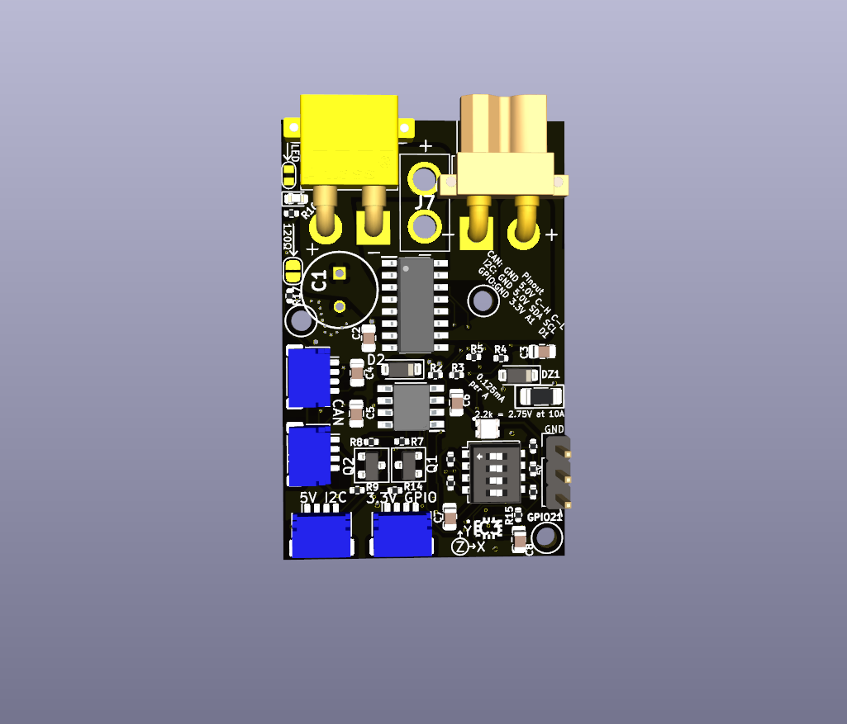

1

2

3

1 2 3 4

1 2 3 4

1

2

3

4

1

2

3

4

**5. Functional Description**

The Daisy Board DC provides robust motor control with precise feedback capabilities.

* **Motor Driver**: The VNH7100BASTR motor driver supports high current loads and features current-sensing capabilities. The sense resistor provides 0.125mA per amp to monitor current.
* **Current Sensing**: A SMD sense resistor enables current feedback targeted for 10A max drive current.
* **6-axis IMU**: The LSM6DS3TR-C IMU provides real-time orientation and motion data for advanced robotics applications.
* **Communication**:
  + CAN Bus allows daisy-chaining of multiple boards.
  + I2C provides expansion for sensors and additional I/O.
* **Configurability**: The onboard DIP switch allows quick CAN address changes without firmware updates.

**6. Assembly Notes**

The PCB comes with the following components pre-assembled:

* Motor driver, CAN transceiver, IMU, and basic passives.

**User-solderable components**:

* 5V regulator
* ESP32 module
* XT30 connectors (optional: bare wire for cost/space savings)
* Input Capacitor

Ensure proper orientation of the polarized capacitor and XT30 connectors, which are clearly labeled on the PCB. **NO REVERSE POLARITY PROTECTION**

**7. Ordering Information**

* **Part Number**: DaisyBoardDC-ESP32
* **Manufacturer**: Wilson Fabrication
* **Customization Options**: Bare PCB or fully assembled (contact for details).

**8. Sense Resistor Sizing Guide**

The Daisy Board DC features a current feedback system utilizing a sense resistor. The motor driver supplies 0.125 mA per amp to the resistor, generating a voltage that corresponds to the motor current. The target voltage at maximum current should be 3V.

**Example Calculation**

If the motor’s maximum current is 10A:



In this case, a resistor with a value of 2.4kΩ is ideal, so we used the standard 2.2kΩ for the SMD resistor.

**Resistor replacements for low current draw.**

It is possible to replace the current sense resistor with a different value when ordering from a PCB production site or manually replacing the resistor.

**Lookup Table**

| **Max Current (A)** | **Target Voltage (V)** | **Calculated Resistor (kΩ)** | **Standard Resistor (kΩ)** |
| --- | --- | --- | --- |
| 5 | 3.0 | 4.8 | 4.7 |
| 2 | 3.0 | 9.6 | 10 |
| 500mA | 3.0 | 38.4 | 38.3 |
|  |  |  |  |
|  |  |  |  |

**9. Contact Information**

For inquiries, please contact:

* **Email**: Lucas@wilsonfabrication.net
* **Website**: <https://wilsonfabrication.com/contact-us/>